Exhibit D | Restricting Access Across Your Network

BEST PRACTICES
Many of today’s attacks are designed to land and expand throughout victims’ networks. To prevent that, you need to establish barriers between your users and your valued assets.

- Actively inventory all network assets and classify them by risk
- Passwords:
  - Use strong, unique passwords.
  - Contain letters, at least one upper and one lower, numbers, and symbols.
  - They shouldn’t be shared or reused.
  - The use of a password management tool is recommended for the safe and secure storage of complex passwords.
  - That includes using unique local admin passwords. Microsoft’s Local Administrator Password Solution (LAPS) can help make this manageable.
  - Don’t save credentials in browsers as It’s incredibly common for attackers/malware to scrape passwords from browser caches.
  - ENABLE MULTI-FACTOR AUTHENTICATION WHENEVER POSSIBLE. There are a wide variety of free and secure 2FA/MFA tools out there for your use.
  - Enable Account Lockouts thresholds. Microsoft recommends 15-minute lockouts after 10 bad attempts.
- Disable or remove default usernames. Examples include “admin,” “administrator,” “default,” “root,” “user,” etc.
- Eliminate elevated privileges and restrict to those who have a documented need.
- Privileged users should use standard, non-admin accounts by default, and only use their elevated privileged account as necessary, ideally from a privileged access workstation.
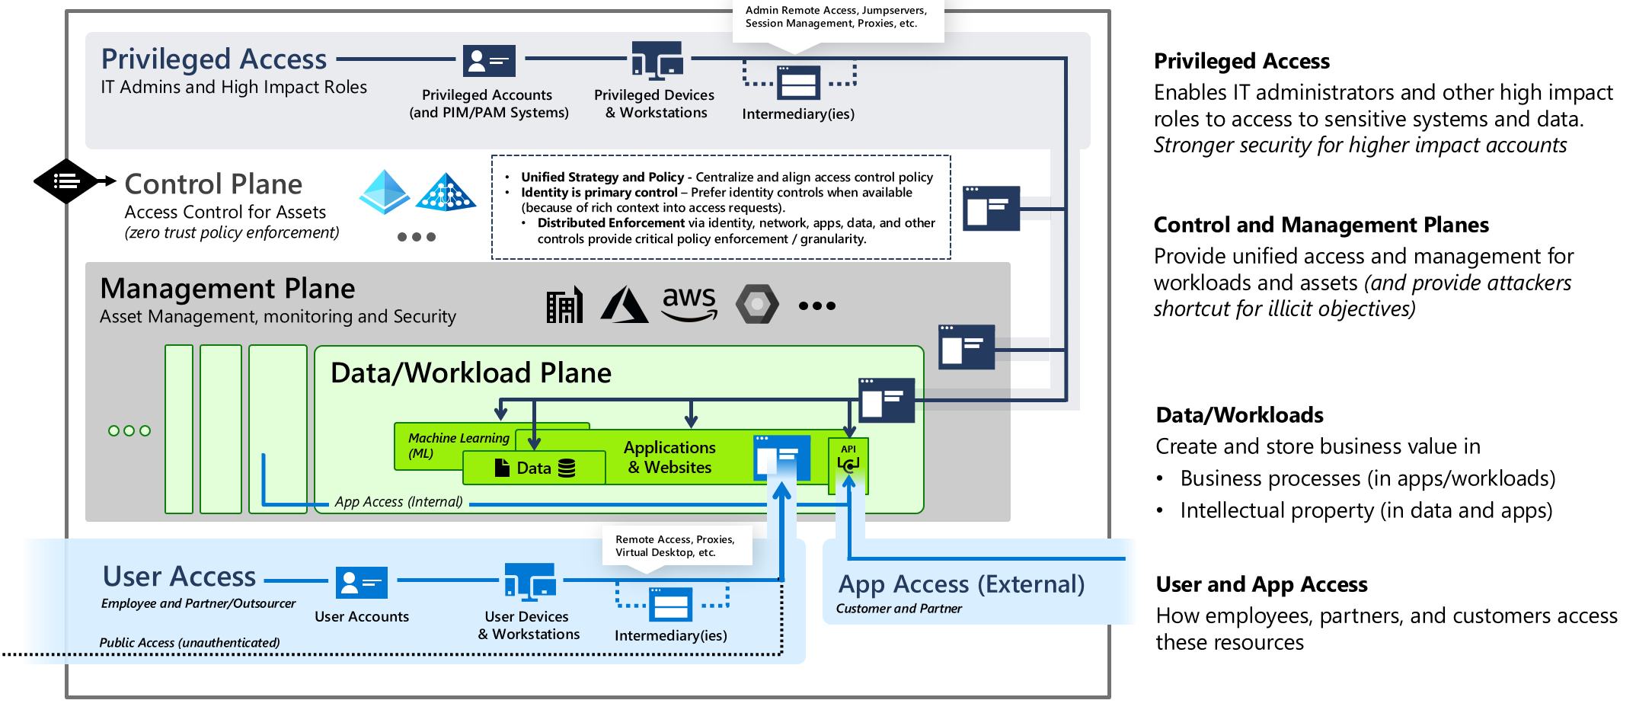

- Create buffers between different levels of privileged access
Microsoft advises adopting a tiered model composed of three levels of admin accounts that each control a different category of assets (domains, servers, and workstations).
The enterprise access model incorporates these elements as well as full access management requirements of a modern enterprise that spans on-premises, multiple clouds, internal or external user access, and more.
- Apply “least privilege” to service accounts.
Creating service accounts for specific applications helps to isolate damage should a single account be compromised.
- Disable services that you don’t require and consider using Group Managed Service accounts to make managing service accounts easier and more secure.
- Remove end users from local admin group. If local admin user credentials get compromised, this can lead to wider network infiltration.
- Audit your domain AND local devices for inactive user accounts
Audit regularly and have a clear policy in place for disabling and deleting accounts when users leave the company.
- Block lateral movement between workstations
By using Active Directory, Group Policy, and Windows Firewall you can prevent workstation-to-workstation communication while still allowing access from your privilege access workstation.
- Limit remote management and access tools and restrict access to those tools
Software like VNC, TeamViewer, etc. are commonly used by threat actors. Ensure that all remote access software is documented and that unneeded remote access tools are removed from the network.
  - Use strong, unique passwords AND multi-factor authentication for ALL remote access tools and management software
  - Keep remote management software up to date
  - Limit remote access from the internet to secured devices through VPN or related secure software systems.
- Limit the use of domain administrator accounts on workstations
- Ensure operating system and software updates and patches are applied at regular intervals.
- Use logging, monitoring, and alerting for remote access sessions. Review these at regular intervals for anomaly detection.
- Conduct vulnerability scans to identify any network or systems weaknesses on a regular basis.
- Log off disconnected and idle sessions
- Enabled automatic screen locks and set to a maximum of 30 minutes.
- Utilize XDR endpoint security software that utilizes machine-learning and/or behavioral analysis to protect network systems and devices.
- Perform regular audits of your firewall policies.
- Utilize DNS and internet filtering systems for all internal systems and devices.
- Utilize a layered email scanning approach to provide multiple points of protection.
- Provide security awareness training to employees.
- Disable or restrict PowerShell access and use.
- Utilize network access and performance monitoring tools.

