Exhibit M – Cybersecurity in Financial Institutions

What is Cybersecurity in Financial Institutions?

Cybersecurity in Financial Institutions refers to the same cybersecurity protocols as normal cybersecurity. However, financial institutions (FI) have regulatory bodies that oversee their cyber security and place specific requirements on them, through two agencies, the FDIC and the NCUA. Both agencies, the FDIC and NCUA get their guidance from multiple entities, with the primary being the FFIEC (Federal Financial Institution Examination Council).

The arrangement of technologies, protocols, and methods referred to as "cybersecurity" is meant to guard against attacks, damage, malware, viruses, hacking, data theft, and unauthorized access to networks, devices, programs, and data.

Protecting the institutions user and member data is the primary goal of cyber security in FI’s.

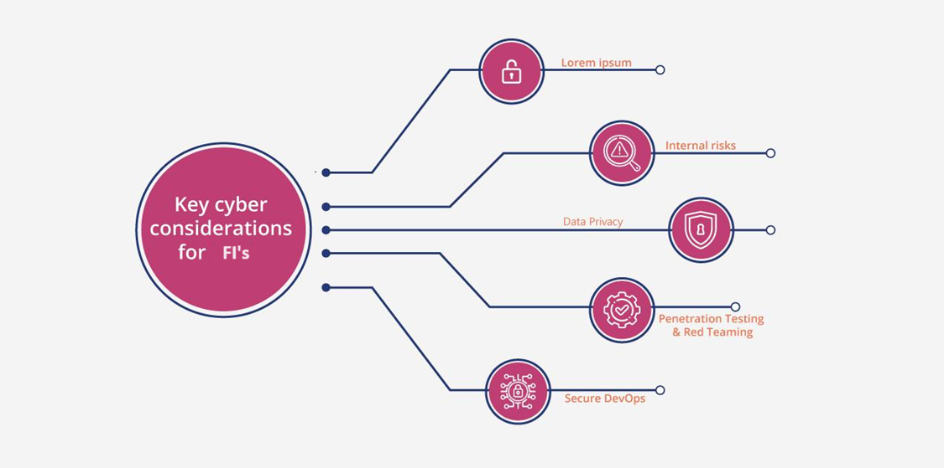

Current State of Cybersecurity in FI’s

The market for IT security in FI’s has maintained its rapid growth in 2024. Since financial institutions are primary attack targets, investments in protection continue to scale. The market value reached $48.19 billion in 2023, and projections see a compound growth rate of 22.4% and a value of $195.5 billion by 2029.

FI’s are mandated to have a strong IT risk governance framework, which includes directives for the CISO (Chief Information Security Officer) or person designated as their ISO (Information Security Officer) to have a proactive role in in ensuring compliance with the necessary standards. The mandates cover that the Board and the Board's Audit Committee should have increased visibility and roles in information security as well.

Reasons Why Cybersecurity is Important in FI’s

FI’s prioritize cybersecurity. Building credibility and trust is a cornerstone of FI’s.

There are five factors that demonstrate the significance of cybersecurity in FI’s industry :
- Payment methods have become increasingly cashless, via debit and credit cards and digital payment methods, such as e-wallets, contactless payments, and payment services such as Zelle, Venmo, and Cash App.
- Financial institutions take significant hits to their reputation after a cyber event, with a loss of confidence in the FI’s ability to keep user and member data safe.
- The impact to users and members when an FI’s systems are down for days can lead to class action lawsuits and damages being awarded due to the impact felt by the consumers.
- Exposure and subsequent Inappropriate use of your private information could be harmful as well. Your data is sensitive and information can be used to commit fraud
- The regulatory agencies can impose harsh penalties on FI’s that suffer breaches.

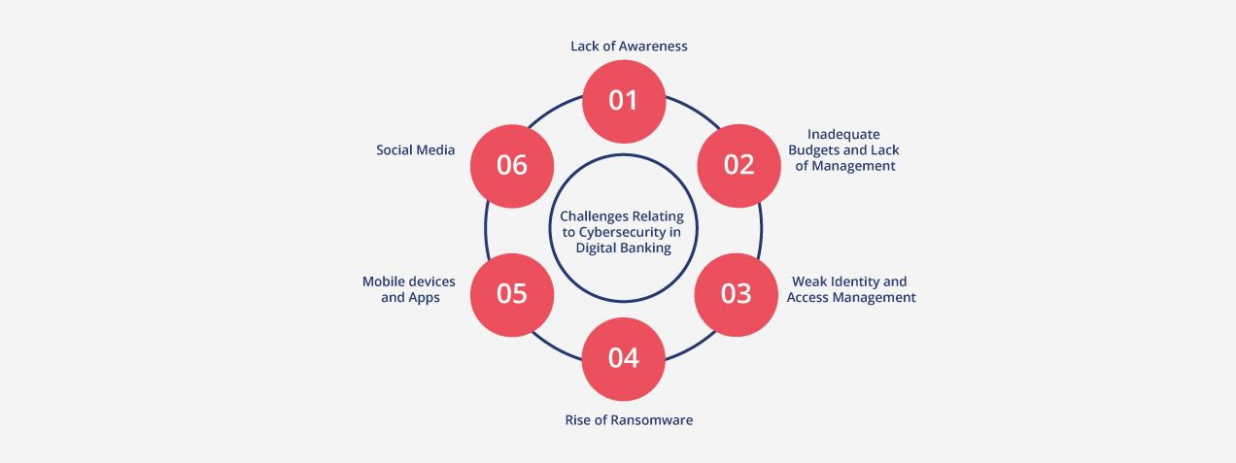

Top Cybersecurity Threats Faced by FI’s

Cybercrimes against FI’s continue to increased year over year and are considered to be one of if not the most significant hazards to the financial sector. Threat actors continuously improve their technology and expertise, making it difficult for the FI sector to keep up. Some of the most common and severe threats are:

- Phishing Attacks
FI’s are under constant assault by phishing. Over 80% of attacks are from phishing, and roughly 36% of ALL information breaches. Phishing attacks can result in an intrusion into the FI, and result in the deployment of ransomware.

- Trojans
The term "Trojan" is used to designate several dangerous tactics attackers use to access to secure data. A financial Trojan looks like trustworthy software, however it will contain malicious computer code created to intercept or access private data processed or kept by online FI’s systems.

- Ransomware
Ransomware encrypts important data and prevents owners from accessing it until they pay a ransom, usually bitcoin, to the attacker. In 2023, roughly 65% of FI’s have reported some type of ransomware event.

- Spoofing
Attackers create a clone of an FI site using some variation of the original URL. By posing as a financial website, they usually attempt to capture credentials and authorization codes. Then the attackers pose as the real consumer on the real FI site and use the captured or passed credentials to gain online account access.

Applications of Cybersecurity in FI’s

As we know, cybersecurity threats are constantly evolving as attackers develop new tools and strategies to compromise FI’s. FI’s must be proactive in learning the new Tactics, Techniques, and Procedures (TTPs )used. In addition, a financial cybersecurity system is generally viewed to be as strong as its weakest link. It is critical to have a selection of cybersecurity tools and approaches available to protect data, systems, and users. While FI’s utilize the same cyber tools as most businesses, there are a couple of key differentiators that FI’s must implement to maintain regulatory compliance.

- Risk Management
Financial institutions must implement robust risk management practices. Essential elements of risk management include risk evaluations of foreseeable threats and vulnerabilities to information assets and the reporting of those risks to senior management and the Board.

- Vendor Management
Financial institutions must implement robust vendor management practices. Essential elements of vendor management include assigning criticality to vendors, performing due diligence of those vendors, and reporting vendor information to senior management and the Board.

Top Cybersecurity Framework for FI’s

A cybersecurity framework provides a common language and set of standards for security leaders across countries and industries to understand their security postures and those of their vendors. With a framework, it becomes easier to define the processes and procedures your organization must take to assess, monitor, and mitigate cybersecurity risk.

Let us take a look at some common financial cybersecurity frameworks:
- COBIT
COBIT stands for Control Objectives for Information and Related Technologies. It's a framework of standards and best practices that helps organizations manage, improve, and implement information technology (IT). COBIT is used by organizations in any industry to ensure the reliability, quality, and control of their IT systems.

- NIST Cybersecurity Framework
Financial institutions are considered critical infrastructure. A Presidential executive order, Improving Critical Infrastructure Cybersecurity, asked for increased cooperation between the public and private sectors for recognizing, analyzing, and managing cyber risk. In response, the NIST Cybersecurity Framework was created. NIST has emerged as the gold standard for evaluating cybersecurity maturity, detecting security weaknesses, and adhering to cybersecurity legislation even when compliance is optional. To achieve NIST compliance, organizations can follow the guidelines outlined in the NIST Cybersecurity Framework and undergo rigorous assessments to ensure they meet the necessary standards.

- Cybersecurity and Privacy Framework for Privately Held Information Systems (the CIPHER Framework)
Computer systems that organizations, both public and private, control and that hold personal data gathered from their clients are referred to as PHISs (Privately Held Information Systems).
CIPHER framework addresses electronic systems, digital information kinds, and methods for data sharing, processing, and upkeep (not paper documents).

The CIPHER methodological framework's primary goal is to suggest procedures and best practices for protecting privately held information systems online (PHIS).

Conclusion
With the requirements placed on FI’s by Federal Agencies and Regulatory bodies, FI’s will continue to be on the forefront of technology processes and practices to keep cyber systems safe.

