Incident
Response
Playbook

Dated: November, 2025

Disclosure

Confidentiality and Distribution
This Incident Response Playbook contains sensitive and proprietary information that is intended solely for the use of authorized personnel within MSP COMPANY NAME. The contents of this document must be treated with the highest level of confidentiality and should not be disclosed, reproduced, or distributed without prior written permission from MSP COMPANY NAME.

Legal Notice
The information contained in this Incident Response Playbook is provided "as is" and for informational purposes only. MSP COMPANY NAME makes no representations or warranties, express or implied, regarding the accuracy, completeness, or reliability of the information. Use of this document is at the user's own risk.

Responsibility and Liability
While every effort has been made to ensure the accuracy and effectiveness of the procedures and guidelines contained within this playbook, MSP COMPANY NAME assumes no responsibility for errors or omissions. The user is responsible for ensuring that their use of this playbook complies with all applicable laws, regulations, and internal policies.

Amendments and Updates
This Incident Response Playbook is subject to change. MSP COMPANY NAME reserves the right to modify, update, or discontinue any part of this document at any time without prior notice. It is the responsibility of the user to ensure they are referencing the most current version of the playbook.

User Acknowledgement
By accessing or using this Incident Response Playbook, the user acknowledges and agrees to the terms and conditions outlined in this disclosure. The user also agrees to maintain the confidentiality of the information and to use it solely for its intended purpose within the scope of their authorized duties.

For any questions or further information, please contact the MSP COMPANY NAME Security Team.

This disclosure ensures that all users understand the sensitivity, legal considerations, and responsibilities associated with the use of the Incident Response Playbook.

Table of Contents

Introduction 1
Cybersecurity Laws in the United States 1
1. Federal Government 1
2. State Government 1
3. Proposed Regulation 2
4. Other Government Efforts 2
What is a Ransomware Incident Response (IR) Playbook? 2
Why is a ransomware IR playbook needed? 2
What Elements should the IR Playbook include? 2
How often should the IR Playbook be Refreshed? 3
The Incident Response Playbook 4
1. Preparation 4
1.1 Policy and Procedures 4
1.2 Roles & Responsibilities 4
1.4 Backup and Recovery 4
1.5 Access Controls 4
1.6 Tools & Resources 4
1.7 Select a Security Framework 4
1.8 Create a Risk Management Plan 5
1.9 How to Implement Cybersecurity Plan for your Business and Best Practices 6
1.10 Common Pitfalls When Implementing Your Cybersecurity Strategy/Plan 7
1.11 Defending Against Evolving Threats 7
1.12 Jump Kit 8
2. Detection & Analysis 9
2.1 Staying Informed 9
2.2 Monitoring and Logging 9
2.3 Incident Reporting 9
3. Containment 10
3.1 Initial Response 10
3.2 Communication 10
4. Preserving Evidence during a Ransomware 10
1.1 Immediate Documentation 10
1.2 Secure and Copy System Logs 10
1.3 Quarantine Affected Systems 10
1.4 Create Forensic Copies 11
1.5 Generate Hashes for All Evidence 11
1.6 Preserve the Chain of Custody 11
1.7 Move Evidence to Secure Storage 11
1.8 Notify Relevant Authorities 11
1.9 Conduct a Detailed Investigation 11
1.10 Review and Learn 11
5. Eradication 12
5.1 Identification 12
5.2 Removal 12
6. Recovery 12
6.1 Data Restoration 12
6.2 System Restoration 12
6.3 Testing 12
7. Post-Incident Activity 13
7.1 Documentation 13
7.2 Analysis 13
7.3 Lessons Learned 13
7.4 Reporting 13
7.5 Example Questions 13
8. Continuous Improvement 14
8.1 Regular Training 14
8.2 Simulation Exercises 14
8.3 Incident Response Plan Review 14
8.4 Preventing Incidents 14
9. Incident Response Teams 15
9.1 Role Considerations 15
8. IT Support Staff 17
Responsibilities: 17
Conclusion 17
10. Key Take-Aways 17
Incident Response Plan Resources 18
Associated Exhibits 19

Exhibit A | Ransomware Response Policy
Exhibit B | Incident Response Procedures
Exhibit C | Incident Response Template
Exhibit D | Restricting Access Across your Network
Exhibit E | Running Regular Simulations
Exhibit F | Understanding the Threat Landscape
Exhibit G | Incident Response Notifications
Exhibit H | Incident Response Alert Sources
Exhibit I | Performing the Forensic Process
Exhibit J | Incident Response Readiness Checklist
Exhibit K | Incident Response Implementation Guidance
Exhibit L | Incident Response Network Management
Exhibit M | Cybersecurity in Financial Institutions

Introduction
Security incident response has become an important component of information technology programs. Because performing incident response effectively is a complex undertaking, establishing a successful incident response capability requires substantial planning and resources. This publication assists organizations in establishing computer security incident response capabilities and handling incidents efficiently and effectively. This publication provides guidelines for incident handling, particularly for analyzing incident-related data and determining the appropriate response to each incident. The guidelines can be followed independently of particular hardware platforms, operating systems, protocols, or applications.

Cybersecurity Laws in the United States

1. Federal Government
In the United States, there are three main federal cybersecurity regulations:
- Health Insurance Portability and Accountability Act (HIPAA) (1996): Enacted by 104th United States Congress, the Health Insurance Portability and Accountability Act attempts to control and modernize medical and healthcare information flow.
- Gramm-Leach-Bliley Act (1999): Enacted by the 106th United States Congress, The Gramm-Leach-Bliley Act made it mandatory for financial institutions, meaning companies that provide consumers products or services like loans, financial or investment advice, or insurance to explain their information-sharing practices to their customers and to safeguard their sensitive data.
- Homeland Security Act (2002): The Homeland Security Act included the Federal Information Security Management Act (FISMA), which attempts to recognize the importance of information security to the economic and national security interests of the United States.
- The Cybersecurity Information Sharing Act (CISA): Encourages the sharing of cyber threat information between the government and private sector.
- The Federal Information Security Management Act (FISMA): Mandates federal agencies to implement comprehensive information security programs.

2. State Government
State government regulations attempt to improve cybersecurity by making valuable information, like organizations with weak cybersecurity, known to the public.
- Notice of Security Breach Act (2003): After this act was enacted, companies that handled sensitive customer data (such as names, credit card numbers, social security numbers, driver’s license numbers, medical records, or financial information) were required to publicly disclose any security or data breach that has happened within their organization.
- California Assembly Bill 1950 (2004): This regulation was passed by the California State Legislature back in 2004 and made a requirement for companies to maintain a reasonable level of cybersecurity, along with extending those security practices to their business partners to maintain an acceptable standard of cybersecurity.

3. Proposed Regulation
Other numerous bills have been proposed by the US Congress over the past few years that expand upon cybersecurity regulations:
- Consumer Data Security and Notification Act: This act expands upon the Gramm-Leach-Bliley Act by requiring financial institutions to disclose any data or security breaches.
- Securely Protect Yourself Against Cyber Trespass Act (SPY ACT): The SPY ACT was passed by the US House of Representatives in 2005 but died in the US Senate. It focused on phishing and spyware scams.
- Cybersecurity Act of 2012: This act also failed to pass the US Senate when it was proposed back in 2012. It proposed anti-cybercrime law and aimed to improve the cybersecurity infrastructure and protect it from cyberattacks, which businesses would be encouraged to adopt through incentives such as liability protection.
- Cybersecurity National Security Action Plan (CNAP): Developed by President Obama in 2016, the main objective of the plan was to create awareness among the public about the growing threat of cybercrimes and inform them how they could improve and control digital security.

4. Other Government Efforts
The federal government of the United States has made attempts to improve cybersecurity by allocating more resources to research and collaborating with the private sector to declare appropriate standards and enact important cyber laws. Besides that, the government has started different awareness programs through social media to make the public more conscious of the threats of cybercrimes.

What is a Ransomware Incident Response (IR) Playbook?
A step-by-step guide that serves as a single source of truth to proactively mitigate, detect, respond, and recover from ransomware incidents. The playbook defines key stakeholders, processes, policies & prevention plans to defend your organization.

Additionally, the playbook should be accompanied by other appropriate plans to ensure their processes are in place to restore normal operations quickly and to comply with applicable regulatory requirements.

Why is a ransomware IR playbook needed?
- To be prepared to act in the event of an attack.
- Limit incident impact to save data, time and money.
- Return to normal business operations as quickly as possible.
- Proactively reduce the risk of future attacks.

What Elements should the IR Playbook include?
- Mission
- Strategies and goals
- Senior management approval
- Organizational approach to incident response
- Incident response team communication
- Measuring the capability and effectiveness of incident response
- Planning for growth of incident response capabilities
- How the program fits into the overall organization

How often should the IR Playbook be Refreshed?
Playbooks are most effective when they stay current, evolve with organizational changes and act as living documents. It’s crucial to identify necessary updates, ownership, and process improvement opportunities on a consistent basis.

As threat landscapes and ransomware tactics are constantly changing, playbook updates are recommended on a semi-annual basis, or if any of the following occur:
- A ransomware incident
- Tabletop exercises, or other dry runs/simulations
- Changes in key business stakeholders
- Major changes in the ransomware ecosystem

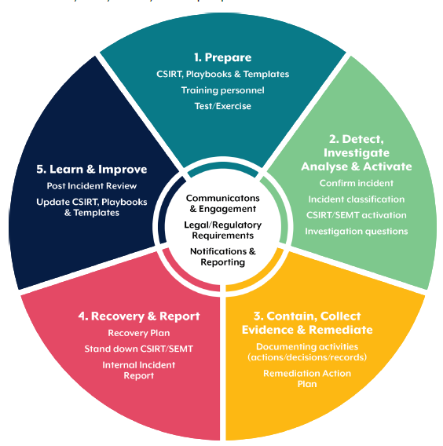

The Incident Response Playbook

- Preparation
  - Policy and Procedures
  - Establish and document a Ransomware response policy.
  - Develop and maintain incident response procedures.
  - Ensure all employees are trained to recognize Ransomware attacks and the appropriate steps to take.

Roles & Responsibilities
- Clearly define key stakeholders, provide up-to-date roles and responsibilities, and outline necessary actions if a Ransomware attack is detected.
  - Security Awareness Training
- Implement a company-wide required security training to communicate dangers of malicious threats and guidance on identifying suspicious activity with steps to protect.
- Educate users on how to report questionable activity to the Security Team.

Backup and Recovery
- Regularly back up all critical data and systems.
- Ensure backups are stored offline or in a separate network.
- Regularly test backup restoration processes.

Access Controls
- Implement strong authentication mechanisms (e.g., multi-factor authentication).
- Limit user permissions based on the principle of least privilege.
- Regularly review and update access controls.

Tools & Resources
- Contact information  - On-call information  - Incident reporting mechanisms  - Issue tracking system  - Smartphones  - Encryption software  - War Room  - Secure storage facility  - Forensic workstations |  | - Laptops  - Spare workstations  - Blank removable media  - Portable printer  - Packet sniffers and protocol analyzers  - Digital forensic software  - Removeable media (Trusted)  - Evidence gathering accessories

Select a Security Framework
Cybersecurity business plan framework allows organizations to understand why Cybersecurity is significant and how the same can be dealt with. It also gives protection on how organizations can lessen the risk of falling victim to any cyber-crimes.

Execution of cybersecurity business plan framework is important as:
- The framework provided is a maturity model that has been fully implemented. Therefore, no additional build-up is required.
- The critical infrastructure of the framework can be implemented in various stages; hence, it seems more effective in businesses. This enables the organization to implement the framework in parts, starting from the lower level and slowly executing to the higher level.
- It provides a measure of the cyber world's current situation and details how the same can be improved with respect to the policies and practices in the Organization.
Based on the requirements of the Organization, different frameworks can be implemented. These are:
- ISO 27001 - The International Organization for Standardization (ISO) Cybersecurity Framework suggests the best practices that an organization can follow to safeguard its critical assets and data.
- PCI DSS - The Payment Card Industry Data Security Standard (PCI DSS) is one of the categories of cybersecurity structures that emphasizes principles for online payments and transactions. It is a set of procedures that aid Enterprises in thwarting fraud while transacting through debit cards, credit cards, prepaid cards, or other forms of the card.
- NIST CSF - National Institute of Standards and Technology (NIST) is one of the topmost industry-leading frameworks for augmenting the basic substance of cybersecurity to recover the groundwork for supervising cybersecurity menaces by using standard techniques and procedures. The five core elements of NIST, which most Organizations follow, are: Protect, Identify, Detect, Recover, and Respond.
- GDPR - The GDPR (General Data Protection Regulation) look around to create a coordinated data protection law framework across the European Union (EU) and work towards giving back to data subjects, being in charge of their data, during staggering strict boundary rules on those hosting and processing this data, anywhere in the world. This framework is also important for controlling and protecting the data from cyber perpetrators.
- HIPPA - The HIPAA cybersecurity rule standards and implementation specifications have four major sections, essentially created to identify relevant security safeguards that help achieve compliance. These are:
  - Physical
  - Administrative
  - Technical
  - Policies, Procedures, and Documentation Requirements

Create a Risk Management Plan
One of the ways to defend against a cybersecurity breach is to design a detailed cybersecurity risk management plan, which needs to be amalgamated into a robust plan that is responsible for all kinds of organizational risk posture. The intention of the cybersecurity risk management plan is to substantiate the Organization's posture towards cybersecurity with respect to safeguarding data from being stolen or lost. The following 8 steps are a guideline for creating a cyber risk management plan.

- Identifying the most valuable Digital Assets: The primary step in creating a cyber risk management plan involves ascertaining the Organization's most valuable digital assets. A list of critical assets to be created with the most susceptible at the highest and to prioritize the most critical list items within the strategy.
- Audit Organization's Data and Intellectual Property: It is essential to perform an audit with respect to Organization's digital assets and data. The audit result's outcome will help create an effective cyber risk management plan.
- Perform a Cyber Risk Assessment: The following step in this process requires carrying out a cyber risk assessment. This particular type of evaluation is designed to identify numerous pieces of information that could be potentially affected by a cyber-attack. The principal goal of a cyber risk assessment is to comprehend where weaknesses exist and curtail gaps in cybersecurity.
- Analyze Security and Threat Levels: Conducting security and threat modeling can help expose pertinent information regarding threat stages and help Enterprises better determine their cybersecurity posture.
- Create an Incident Response Plan: An incident management and response plan are a consolidated module of instructions configured toward different cybersecurity threats such as cyber-attacks, data loss, service outages, and many other events that pessimistically impact normal business operations. The plan can effectively help to detect, respond and recover from cybersecurity incidents. The incident response plan eventually embeds the cybersecurity recovery plan from a business continuity standpoint.

How to Implement Cybersecurity Plan for your Business and Best Practices
Having a cybersecurity implementation plan from the start and continuing it throughout the development cycle is an industry best practice. However, the process is monotonous and requires detailed planning before execution. Below are the steps to implement a cybersecurity plan:
- Build a Cybersecurity Team
The first step in a cybersecurity management plan is to build a dynamic team. This team designs and builds the framework of the security program, monitors the threats and responds to the incidents.
- Inventory and Manage Assets
The cybersecurity team's initial screening is to understand the assets that exist location of those assets, make sure the assets are tracked, and secure them properly. In other words, it is time to prepare a catalog of everything that could contain sensitive data, from hardware and devices to applications and tools (both internally and third-party developed) to databases, shared folders, and more. Once the list is prepared, the same is assigned to each asset owner, and then the same is categorized by importance and value.
- Assess the Risk
Thinking about risks, threats & vulnerabilities is indispensable to evaluating risk. A list of probable threats to the Organization's assets should be made ready, and then a numeric score to designate these threats based on the likelihood and impact. The numeric score can be classified and ranked accordingly based on potential impact. Vulnerabilities identified from these assets can comprise people (employees, clients, and third parties), processes, and technologies in place.
- Manage Risk
As the ranking of the list that has been prepared by assessment, it can be decided whether Organization wants to reduce, transfer, accept, or ignore each risk.
- Reduction of risk: Recognize and implement fixes to counter the risk (e.g., put in place a firewall, set up local and backup locations, implement DLP tools to curb phishing emails, etc.).
- Transferring risk: Buy an insurance policy for assets or collaborate with a third party to transfer that risk.
- Accepting the risk: Accepting the risk when the value of countermeasures is greater than the loss amount.
- Avoiding the risk: This occurs when Organization contradicts the existence or probable impact of a risk, which is not recommended as it can lead to irreversible consequences.
- Apply Security Controls
For the risks that have been identified, controls should be implemented. These controls will alleviate or eradicate risks. They can be technical (e.g., encryption, intrusion detection and prevention software, antivirus, firewalls, anti-malware, and phishing software) or non-technical (e.g., policies, procedures, physical & logical security, and employees). Security controls are to be implemented accordingly as per the technical / non-technical aspect.
- Audit
A complete cybersecurity audit program should be in place to understand the standpoint with respect to Organization's Threat Matrix. This can help the Organization identify the Root Cause of the incident as well.

Common Pitfalls When Implementing Your Cybersecurity Strategy/Plan
The following list is the most common areas that should be avoided while implementing the cybersecurity plan:
- Denial of Common Cyber Threats
- Neglecting Regular Software Updates
- Falling for Common Cyber Threats
- No Training for Employees
- Not Creating Strong Passwords
- No Cybersecurity Policy
- Not Protecting Business Data

Defending Against Evolving Threats
As a cybersecurity professional, I've learned the importance of educating my team on cyber threats and prevention strategies. Equipping them with knowledge is like empowering them with superpowers to identify and thwart potential attacks. The necessity for constant monitoring and adaptable security measures is underscored by the fact that hackers are keeping up with this rapid evolution, even as we predict further innovation in 2024. Here are the best practices you can follow in 2024.
- Update Your Cyber Tools Regularly: Just like upgrading your phone's software, regularly update your cybersecurity tools. It's like getting the latest superhero suit to defend against latest cybersecurity threats.
- Train Your Team to be Cyber savvy: Educate your team on cyber threats and prevention strategies. Think of it as giving them superpowers to identify and thwart potential attacks.
- Invest in AI Super Shields: Artificial Intelligence (AI) is your digital sidekick. Implement AI-driven solutions to detect and respond to cybersecurity issues and challenges faster than any human could. It's like having a superhero with super speed on your team.
- Lock Down Your Digital assets: Secure access points like you're protecting a treasure chest. Limit who can enter, ensuring only the trusted few have the keys to your digital kingdom. Secure access points like you're protecting a treasure chest. Limit who can enter, ensuring only the trusted few have the keys to your digital kingdom.
- Encrypt Messages and sensitive data: Encrypt sensitive data to make it unreadable to unauthorized eyes. It's the digital equivalent of sending secret messages that only your allies can decipher.
- Backup Data: Regularly back up your data. Think of it as creating a safety net against emerging challenges in cybersecurity – even if a cyber disaster strikes, you can bounce back with minimal damage.
- Collaborate with experts: Collaborate with others in the digital community. It's like being part of a superhero league where information about incoming threats is shared, making everyone stronger.: Collaborate with others in the digital community. It's like being part of a superhero league where information about incoming threats is shared, making everyone stronger.
- Bolster Your Digital Defenses: Strengthen your firewall and antivirus software. It's akin to reinforcing the walls of your digital castle to withstand the ever-evolving siege of cyber threats. Bolster Your Digital Defenses: Strengthen your firewall and antivirus software. It's akin to reinforcing the walls of your digital castle to withstand the ever-evolving siege of cyber threats.
- Implement Multi-Factor Authentication (MFA): Add an extra layer of security with MFA. It's like having a double lock on your digital door – even if one key is stolen, the other keeps your data safe. Implement Multi-Factor Authentication (MFA): Add an extra layer of security with MFA. It's like having a double lock on your digital door – even if one key is stolen, the other keeps your data safe.
- Stay Agile and Ready for Action: Cybersecurity new challenges are like supervillains – always evolving. Stay agile and ready to adapt your cybersecurity strategy. It's the key to staying one step ahead in the cyber game of cat and mouse.

Jump Kit
Jump kits are portable, ready-to-go cases that contain the tools and resources a responder would need in the event of an incident.
- A portable case that carries items needed for an investigation.
Should always be ready to go
- Contains hardware, software, and other response items:
Cables, blank media, hard copies of documents
- Two laptops per incident handler is recommended:
One for malware analysis and one for actions that could infect the laptop

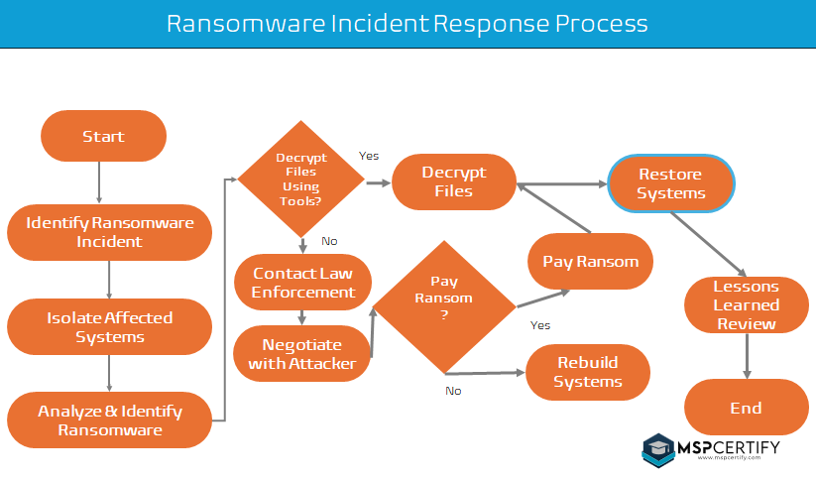

2. Detection & Analysis

2.1 Staying Informed
- Stay informed in common attack vectors used in ransomware attacks. Strategize and document security detection and response plans, they may differ depending on the method of attack. In addition, create process flow to show the end-to-end process of incidents detected, reported, triaged, and resolved.
- According to NIST, common attack methods include email attachments and embedded malicious links, web browser vulnerabilities, infected programs bundled with malware and portable USB devices.
- Incident response teams should implement consistent methods of evaluating and prioritizing Ransomware events to determine required escalations. Create an incident impact matrix to determine required escalation.

Monitoring and Logging
- Set up continuous monitoring for suspicious activities.
- Ensure logging is enabled for all critical systems and applications.
- Use SIEM (Security Information and Event Management) tools to correlate and analyze logs

2.3 Incident Reporting
- Establish clear channels for reporting suspected Ransomware incidents.
- Encourage employees to report any suspicious activity immediately.
2.4 Indicators of Compromise (IoCs)
- Maintain a list of known IoCs related to Ransomware.
- Regularly update IoCs and ensure monitoring tools are configured to detect them.

3. Containment

3.1 Initial Response
- Immediately isolate the affected systems to prevent the spread of Ransomware.
- Disconnect the infected devices from the network.

3.2 Communication
- Notify the incident response team and relevant stakeholders.
- Avoid using the compromised systems for communication.

3.3 Temporary Mitigation
- Implement temporary access controls to limit further damage.
- Use network segmentation to contain the Ransomware.

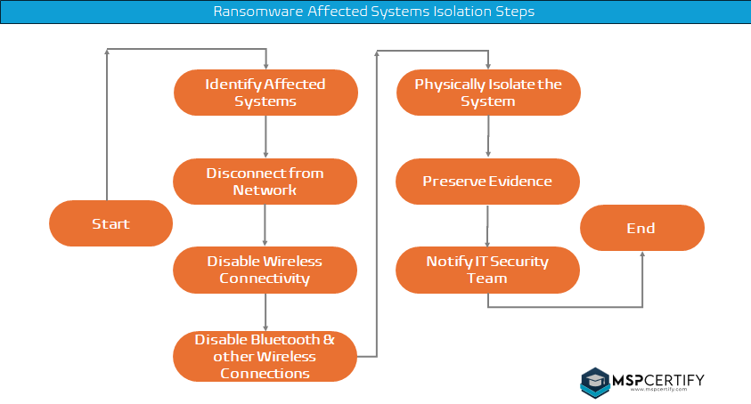

4. Preserving Evidence during a Ransomware
Preserving evidence during a ransomware attack is crucial for understanding the attack vectors, mitigating damage, and potentially pursuing legal action against the attackers. Here are the key steps to preserve evidence:
  - Immediate Documentation
As soon as you identify a ransomware attack, start documenting everything related to the incident. This includes timestamps, user reports, and any visible indicators of compromise.
  - Secure and Copy System Logs
Quickly secure and copy all system logs, including those from operating systems, security solutions, and network equipment. These logs are crucial for forensic analysis. Ensure that copies are made before any system changes occur that might overwrite relevant data.
  - Quarantine Affected Systems
Isolate compromised systems from the network to prevent the spread of ransomware and to preserve their state for forensic investigation. This involves disconnecting from the network, disabling wireless functionalities, and not powering down the machines, as doing so may lose volatile data important for analysis.
  - Create Forensic Copies
Make bit-by-bit copies of affected systems and storage devices. These copies, often referred to as forensic images, allow investigators to analyze the full extent of the compromise without risking the integrity of the original evidence.
  - Generate Hashes for All Evidence
Use cryptographic hashing tools to generate hashes (e.g., SHA-256) of forensic images and other pieces of evidence. Hashes serve as digital fingerprints to ensure that evidence remains unaltered from the point of capture to its presentation in any legal proceedings.
  - Preserve the Chain of Custody
Document how evidence is collected, transferred, and stored, including who has had access to it. Maintaining a clear chain of custody is essential for ensuring the admissibility of evidence in legal contexts.
  - Move Evidence to Secure Storage
Transfer all collected evidence to a secure, access-controlled environment. This prevents unauthorized access and protects the integrity of the evidence.
  - Notify Relevant Authorities
Inform law enforcement and other relevant authorities about the incident. Collaboration with these entities can provide additional resources for investigation and recovery.
  - Conduct a Detailed Investigation
With the preserved evidence, conduct a thorough investigation to understand how the attack happened, the extent of the damage, and the specific ransomware variant involved. This step often involves cybersecurity professionals or a digital forensics team.
  - Review and Learn
Use the findings from the investigation to strengthen your organization's cybersecurity posture. This includes patching vulnerabilities, enhancing monitoring capabilities, and updating incident response plans based on lessons learned.

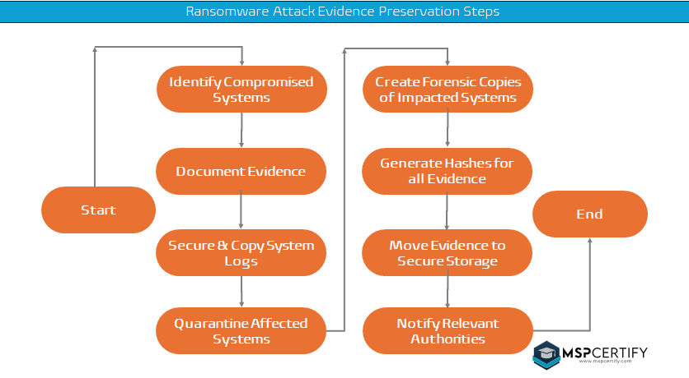

Eradication

5.1 Identification
- Identify the Ransomware variant and its behavior.
- Determine the extent of the infection and all affected systems.

5.2 Removal
- Use anti-malware tools to remove the Ransomware from affected systems.
- Ensure all traces of the Ransomware are eradicated.
5.3 Vulnerability Mitigation
- Identify and address the vulnerabilities that were exploited.
- Apply necessary patches and updates to prevent future incidents.

Recovery

6.1 Data Restoration
- Restore data from clean backups.
- Verify the integrity of restored data.

6.2 System Restoration
- Rebuild or restore affected systems.
- Ensure systems are fully patched and secured before reconnecting to the network.

6.3 Testing
- Conduct thorough testing to ensure systems are free of Ransomware.
- Validate that all systems are functioning correctly post-recovery.

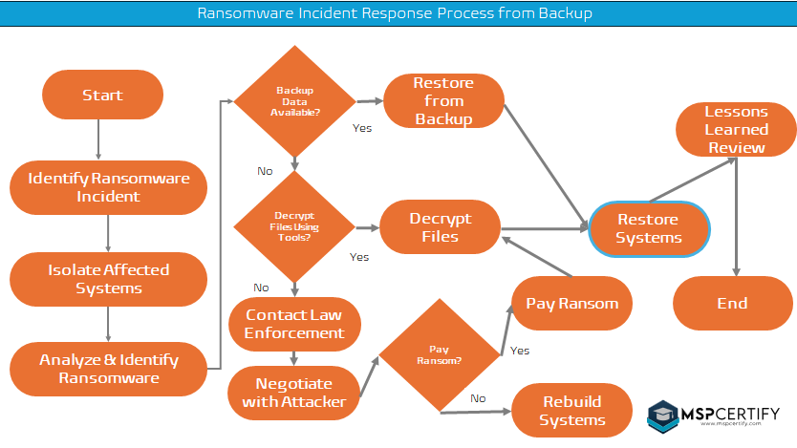

Post-Incident Activity

7.1 Documentation
- Document the incident, including the timeline, actions taken, and lessons learned.
- Maintain detailed records of the incident response and recovery process.

7.2 Analysis
- Perform a root cause analysis to understand how the Ransomware entered the network.
- Assess the effectiveness of the response and identify areas for improvement.

7.3 Lessons Learned
- Hold a post-incident review meeting with all stakeholders.
- Update policies, procedures, and training based on the findings.

7.4 Reporting
- Report the incident to relevant authorities if required (e.g., data protection authorities).
- Communicate the incident and response actions to relevant internal and external parties.

7.5 Example Questions
- What happened, at what time?
- How well was the staff performance?
- What information was needed sooner?
- Did any steps inhibit recovery?
- What would you do differently next time?
- Could information sharing be improved?
- Can corrective actions be implemented?
- Were additional tools or resources needed?

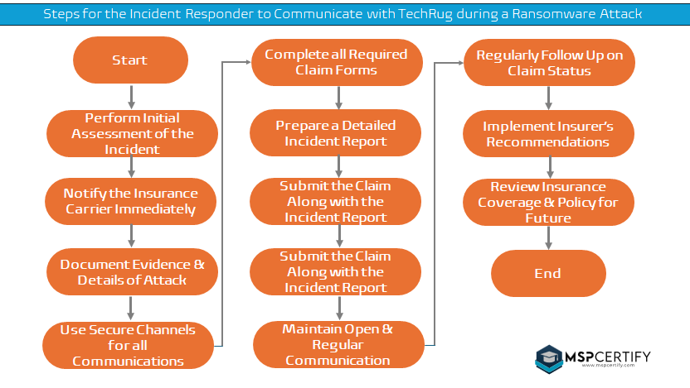

Continuous Improvement

8.1 Regular Training
- Conduct regular training sessions for employees on Ransomware and other cyber threats.
- Update training materials based on the latest threat intelligence.

8.2 Simulation Exercises
- Conduct regular tabletop exercises and simulated Ransomware attacks.
- Test and refine the incident response plan regularly.

8.3 Incident Response Plan Review
- Regularly review and update the incident response plan.
- Ensure the plan aligns with current best practices and threat landscape.

8.4 Preventing Incidents

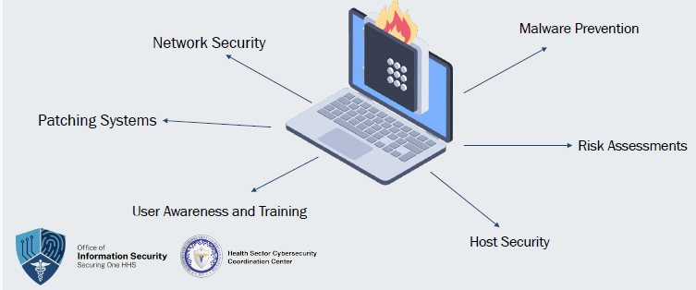

Incident Response Teams
Team Structure/Model | Type | Use
Central incident response team | Single response team | Smaller organizations; minimal geographic diversity
Distributed incident response team | Multiple response teams | Larger organizations; one team per segment/region
Coordinating team | Provides advice to teams | Lacks authority
Staffing Models
Employees | Partially outsourced | Fully outsourced

9.1 Role Considerations
  - IR Managers
  - Security Analysts
  - Threat Researchers
  - Other

An Incident Response Team (IRT) is a group of professionals dedicated to managing and mitigating cybersecurity incidents within an organization. This team is responsible for identifying, assessing, responding to, and recovering from security incidents, ensuring minimal impact on business operations and data integrity. The following document outlines the key roles and responsibilities within an IRT.

1. Incident Response Team Lead
Responsibilities:
Overall Coordination: Oversee the incident response process from identification to resolution.
Decision Making: Make critical decisions regarding incident response strategies.
Communication: Act as the primary point of contact between the IRT and senior management.
Reporting: Document incidents and response activities, providing regular updates to stakeholders.
Training & Awareness: Ensure the team is adequately trained and conducts regular incident response drills.

2. Incident Analyst
Responsibilities:
Monitoring & Detection: Continuously monitor security alerts and indicators of compromise.
Initial Triage: Assess the severity and impact of detected incidents.
Investigation: Analyze logs, network traffic, and other data sources to determine the nature and scope of incidents.
Documentation: Record detailed findings and actions taken during the investigation.

3. Incident Responder
Responsibilities:
Containment: Implement measures to contain the incident and prevent further damage.
Eradication: Identify and remove the root cause of the incident.
Recovery: Restore affected systems and services to normal operation.
Post-Incident Analysis: Conduct a thorough review of the incident and response efforts to identify improvements.

4. Threat Intelligence Analyst
Responsibilities:
Threat Assessment: Gather and analyze threat intelligence to understand potential risks and attack vectors.
Contextualization: Provide context to incidents by correlating with threat intelligence data.
Reporting: Produce threat intelligence reports to inform decision-making and proactive defenses.
Collaboration: Work with external threat intelligence communities and share relevant findings.

5. Forensic Analyst
Responsibilities:
Evidence Collection: Gather and preserve digital evidence in a forensically sound manner.
Analysis: Examine collected evidence to reconstruct the timeline and impact of incidents.
Reporting: Prepare detailed forensic reports to support incident response and potential legal actions.
Chain of Custody: Maintain the integrity and chain of custody for all collected evidence.

6. Legal Advisor
Responsibilities:
Legal Compliance: Ensure all incident response activities comply with relevant laws and regulations.
Data Protection: Advise on data protection and privacy implications of incidents.
Liaison: Act as a liaison with law enforcement and regulatory bodies if necessary.
Documentation: Assist in the documentation and preservation of evidence for potential legal proceedings.

7. Communication Specialist
Responsibilities:
Internal Communication: Ensure timely and accurate communication within the organization during an incident.
External Communication: Manage communications with external stakeholders, including customers, partners, and the media.
Messaging: Develop clear and consistent messaging to minimize reputational damage.
Crisis Management: Support the development and execution of a crisis communication plan.

8. IT Support Staff

Responsibilities:
- Technical Assistance: Provide technical support for containment, eradication, and recovery efforts.
- System Restoration: Assist in the restoration of affected systems and services.
- Patch Management: Ensure timely application of security patches and updates.
- Infrastructure Support: Maintain the infrastructure needed for effective incident response.

Conclusion
The success of an Incident Response Team depends on clearly defined roles and responsibilities, effective communication, and ongoing training. By having a well-structured IRT, organizations can ensure a swift and coordinated response to cybersecurity incidents, minimizing impact and enhancing overall security posture.

Key Take-Aways
- Incident Response Plans provide detailed guidelines for organizations.
- Organizations can follow and adopt widely accepted best practices.
- Creates a standardized and common language for approaching incidents.
- NIST Incident Response Plans emphasize quick and coordinated responses.
- Engaging in post-incident analysis encourages continuous improvement.
- Creates opportunity to learn from mistakes, identify vulnerabilities, and enhance planning.

Incident Response Plan Resources

NIST Guidance:
https://nvlpubs.nist.gov/nistpubs/SpecialPublications/NIST.SP.800-61r2.pdf
NIST Contingency Planning:
https://nvlpubs.nist.gov/nistpubs/Legacy/SP/nistspecialpublication800-34r1.pdf
Coordinated Healthcare Incident Response Plan (CHIRP):
https://healthsectorcouncil.org/wp-content/uploads/2023/07/HIC-CHIRP-FINAL_1.pdf
CISA Guidance:
https://www.cisa.gov/sites/default/files/2024-03/Federal_Government_Cybersecurity_Incident_and_Vulnerability_Response_Playbooks_508C.pdf
CISA Incident Response Plan Basics: https://www.cisa.gov/sites/default/files/publications/Incident-Response-Plan-Basics_508c.pdf
ASPR HPH Cybersecurity Framework Implementation Guide:
https://aspr.hhs.gov/cip/hph-cybersecurity-framework-implementation-guide/Documents/HPH-Sector-CSF-Implementation-Guide-508.pdf
ASPR TRACIE (National Response Framework):
https://asprtracie.hhs.gov/technical-resources/resource/1746/national-response-framework
ASPR Incident Response Framework:
https://aspr.hhs.gov/ResponseOperations/Documents/Incident-Resp-Framework-508.pdf
National Cyber Incident Response Plan:
https://www.cisa.gov/sites/default/files/ncirp/National_Cyber_Incident_Response_Plan.pdf

Associated Exhibits

Exhibit A | Ransomware Response Policy
Exhibit B | Incident Response Procedures
Exhibit C | Incident Response Template
Exhibit D | Restricting Access Across your Network
Exhibit E | Running Regular Simulations
Exhibit F | Understanding the Threat Landscape
Exhibit G | Incident Response Notifications
Exhibit H | Incident Response Alert Sources
Exhibit I | Performing the Forensic Process
Exhibit J | Incident Response Readiness Checklist
Exhibit K | Incident Response Implementation Guidance
Exhibit L | Incident Response Network Management
Exhibit M | Cybersecurity in Financial Institutions

